**University of Technology and Applied Sciences**

**IT Department**

Course Code: **CSDS3105** Course Title: **Database Programming**

Lecturer Name:  **Mohamed Ali N.M.A** Semester : Spring – 2024-2025

**Class Activity –Procedure and Function**

Nizwa Store sells bread, cookies, cakes, pastries and chocolates. It has many branches across Oman. They are using **Store** Management Software solution to manage their sales details. This software solution is using **STORE** database schema to record the stores, products, salesman and sales details. Use this schema and answer all the questions.

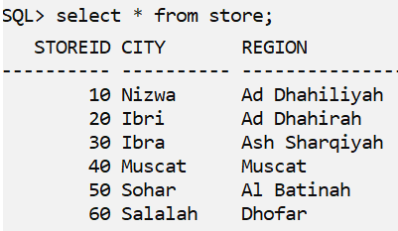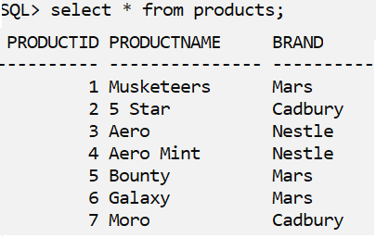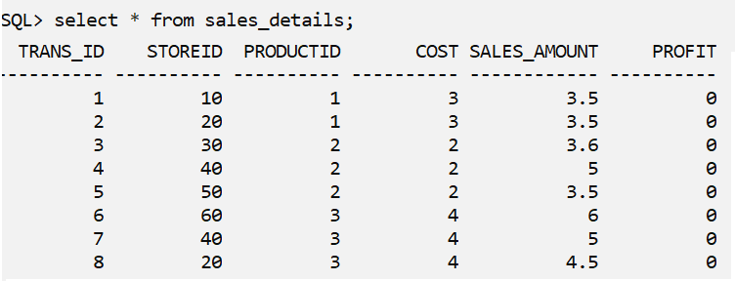

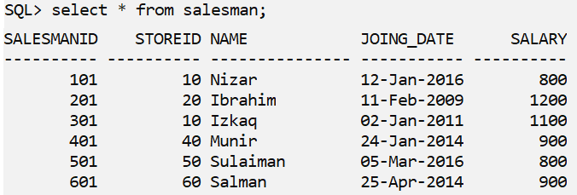

1. Create a PL/SQL procedure named **LIST_PRODUCTS** that takes product brand name as an input parameter and displays all the products related to the brand.

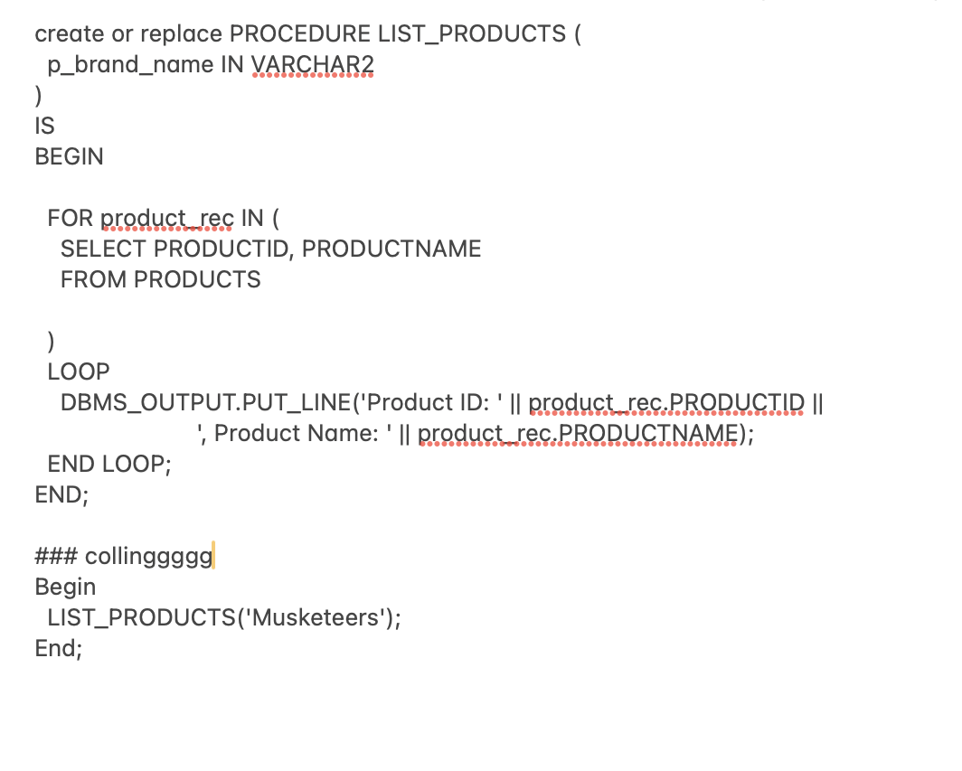

1. Create a procedure called **insert_products** which will insert a new product record into PRODUCTS table. Pass the product id, name and brand to the procedure as IN parameters and insert the record. The procedure should not allow inserting the record if product id is more than 100 and display appropriate error message.
2. Create a function **INCREASE_SALARY** that takes salary , increment rate as the input parameters and returns increased salary based on increment rate.

Increased Salary = Salary +( Salary * increment rate )

1. Create a procedure **PROC_UPDATE_SALARY**  that increases the salary of each employee in the salesman table based on the following criteria.

|  |  |
| --- | --- |
| ***Total years Experience*** | ***Increment*** |
| *More than 5 years* | *20 percent of current salary* |
| *Otherwise* | *15 percent of current salary* |

The procedure has to invoke the **INCREASE_SALARY** function to get the increased salary amount by passing current salary and appropriate increment rate.

1. Create a procedure **PROC_REPORT** that displays salesman Id, name, city and salary for all the salesman.

CREATE OR REPLACE PROCEDURE PROC_REPORT IS

BEGIN

FOR rac IN (

SELECT sa.salesmanid, sa.name, sr.city, sa.salary

FROM salesman sa

JOIN store sr ON sr.storeid = sa.storeid

) LOOP

DBMS_OUTPUT.PUT_LINE(

'ID: ' || rac.salesmanid ||

', Name: ' || rac.name ||

', City: ' || rac.city ||

', Salary: ' || rac.salary

);

END LOOP;

END;

Begin

PROC_REPORT();

end;